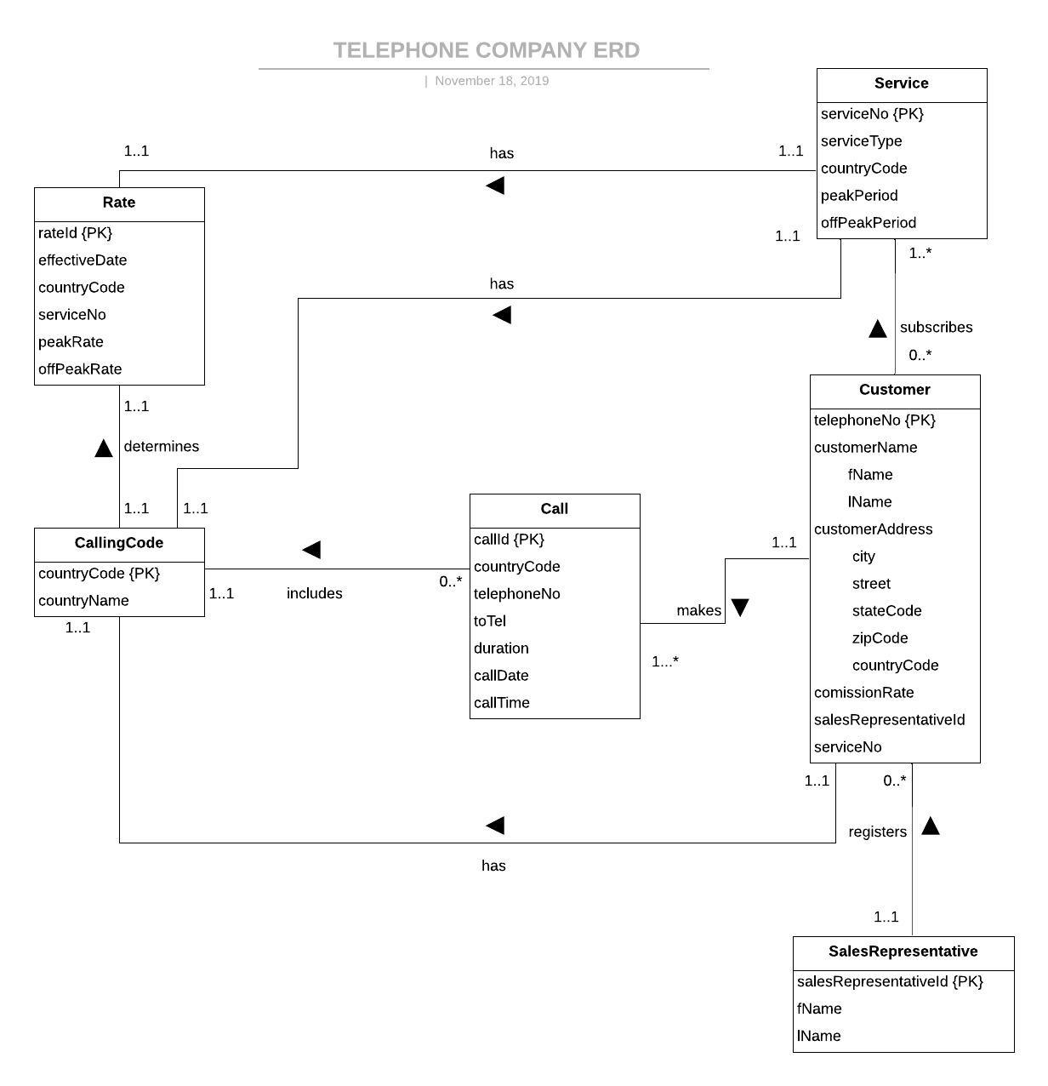 **Customer**

* **Many : Many participations with service**
* **1: Many with call**
* **Mandatory with salesRepresentative**

**Service**

* **Mandatory participation with Rate**
* **Many : Many participations with Customer**

**Rate**

* **1:1 Mandatory with service**
* **1:1 Mandatory with CallingCode**

**Call**

* **Mandatory participation with CallingCode**
* **Mandatory participation with Customer**

**CallingCode**

* **Mandatory with Rate**
* **1:Many with Call**

**SalesRepresentative**

* **1: Many with Customer**

**Customer (**telephoneNo, fName, lName, zipCode, city, street, stateCode, country, comissionRate, salesRepresentativeId, serviceNo**)**

**PK:** telephoneNo

**FK:** salesRepresentativeId References SalesRepresentative(salesRepresentative)

**Service (**serviceNo**,** serviceType, countryCode, peakPeriod, offPeakPeriod**)**

**PK:** serviceNo

**FK:** countryCode References CallingCode(countryCode)

**Rate (**rateId**,** effectiveDate, countryCode, serviceNo, peakRate, offPeakRate**)**

**PK:** rateId

**FK**: countryCode References CallingCode(countryCode)

**FK**: serviceNo References Service(serviceNo)

**AK:** effectiveDate, toCode, serviceNo

**CallingCode (**countryCode, countryName**)**

**PK:** countryCode

**AK**: countryName

**Call (**callId, countryCode, telephoneNo, toTel, duration, callDate, callTime**)**

**PK:** callId

**FK:** countryCode References CallingCode(countryCode)

**FK**: telephoneNo References Customer(telephoneNo)

**SalesRepresentative (**salesReperesentativeId, fName, lName**)**

**PK:** salesReperesentativeId

**\*: * relationship**

**customerServices (**custServiceId**,** customerName, serviceNo, telephoneNo**)**

**PK :** serviceId

**FK**: serviceNo References Service(serviceNo)

**FK**: telephoneNo References Customer(telephoneNo)

**AK**: telephoneNo, serviceNo